February 2023
Volume 1 Issue 2
Renewed Remembering

The Newsletter of the Conneaut Historical Society

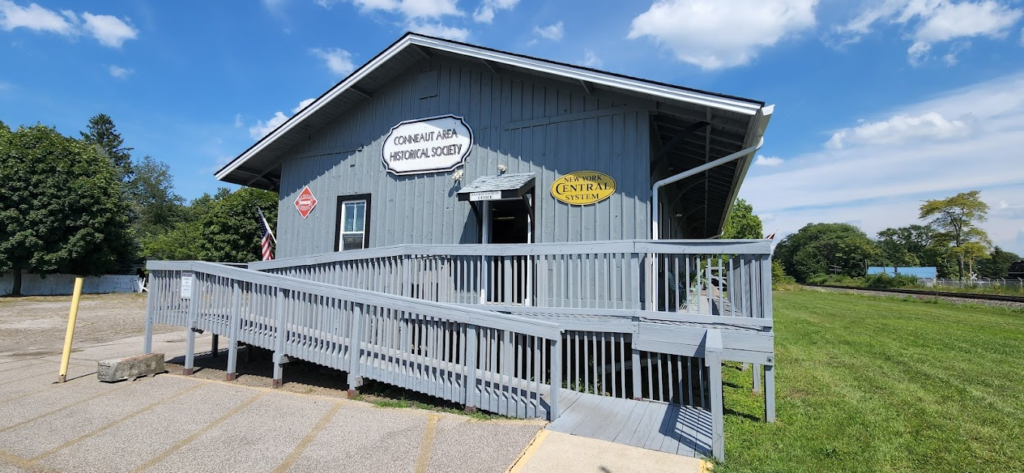
A Message from President Jim Jones
The Conneaut Area Historical Society wants to thank all members who have been prompt with their dues. However, due to Covid and the loss of our Secretary, Joan Barnett, we no longer have a newsletter being sent to members. We are asking you again for your support because utilities, taxes, and upkeep on the building must be maintained. Thank you again for your continued support. As always, new members are welcome.
You can call: 440-593-3019 with further questions or write to Conneaut Area Historical Society, P.O Box 563, Conneaut, Ohio, 44030.
Thanking you in advance. Jim Jones, President, Conneaut Area Historical Society
Please pick up a copy of this newsletter and share it with your friends. Or read your copy on our Conneaut Historical Society website: https://capturingconneauthistory.com/
Inside: Time Travel Tuesdays, Awesome Astatic, Hump Day History and more!

Time Travel Tuesdays


February 21, 2023 -Jeff Morrell – “The Majestic Theater and other Theaters in Conneaut”
March 21, 2923 -Bob Lebzelter – “The Youngest Prisoner Executed in Ohio was from Conneaut”
April 18, 2023- Dave Beckwith- “Ore Boats on The Great Lakes”
Day and Date
3rd Tuesday of the month
Time
6 to 7 p.m.
Place
Conneaut Public Library

Society Notes
“Remembering” was the name of the original Conneaut Area Historical Society newsletter. Joan Barnett was the last editor, and with her death and the Covid pandemic the newsletter hasn’t been published for a time. It seemed fitting to name this new version of the old newsletter “Renewed Remembering,” in honor of the former editors including Louise Legeza and Joan Barnett who edited and published the newsletter for so many years.
This last year featured a renovated Conneaut Historical Society, both inside and out. Volunteers cleaned, rearranged, and renovated inside exhibits and the frame based picture feature is being reimagined as well as the collections and shelving being reorganized. The Museum now has a website which we hope all of you will visit, read the historical articles, and watch the historical videos. The website address is: https://capturingconneauthistory.com/

We are also presenting a monthly program of speakers on historical topics at the Conneaut Public Library. Please get involved and help us in our goal of preserving and presenting Conneaut History


Hump Day History to Wisk Away Weary Wednesdays
Conneaut Confusion
KELA EIRE ___________________________________
SMESO ENDCAELVLA _________________________
INRO EOR__________________________________________
NCOUTENA RECKE__________________________________
IHLOEUTHSG________________________________________
AESLM_____________________________________________
TSUALABAH YUCONT_______________________________
LTTEHU______________________________________________
KODSC_______________________________________________
OAALRRDI USMEMU___________________________________
AUOETNNC RYBARLI___________________________________
BLFFAOU SEERTT______________________________________
WRENAD CENREAGI____________________________________
TFAURNUNMGIAC_______________________________________
ILBNSEGS OF ETH EFTLE__________________________________
OEUTR NWTTYE__________________________________________

Conneaut Confusion Questions and Answer Key
- Conneaut’s Lake
- Leader of party surveying what later would be Conneaut.
- Important trade between Minnesota and Conneaut.
- This river, famous for its fishing, empties into Lake Erie.
- Watches over Conneaut harbor.
- One of Conneaut’s earlier names.
- County of Conneaut
- George invented this.
- Andrew Carnegie built these.
- Famous for its trains.
- Andrew Carnegie built the first one.
- This first one was located on this street.
- He bought the land for the P& C Docks and Silent City.
- Conneaut once was noted for its
- This happened every year to open the shipping season.
- The main highway through Conneaut.

MOSES CLEAVELAND ROUTE TWENTY
SALEM BLESSING OF THE FLEET
LAKE ERIE BUFFALO STREET
DOCKS MANUFACTURING
CONNEAUT CREEK
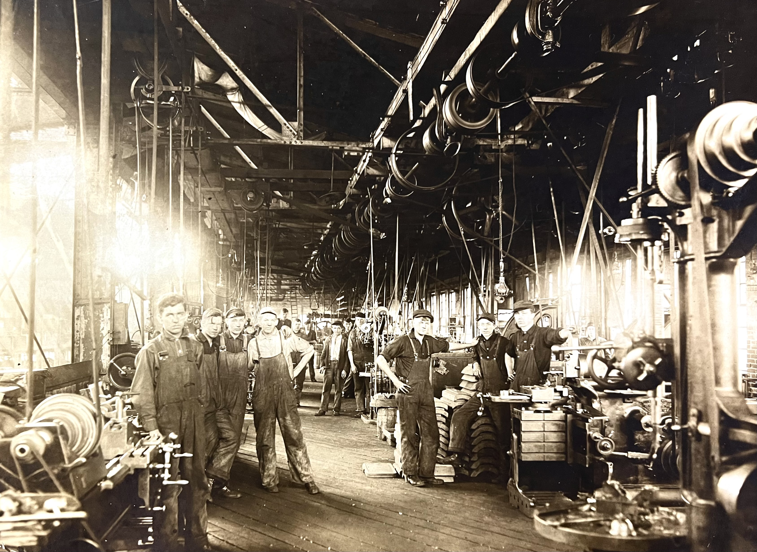
IRON ORE
LIGHTHOUSE
HULETT
ASHTABULA COUNTY
RAILROAD MUSEUM
CONNEAUT LIBRARY
\ANDREW CARNEGIE
Fantastic Astatic: Transforming an Idea into an Industry
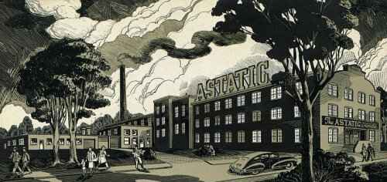

Conneaut wintry weather on the night of January 17, 2023 didn’t keep Carl Rowbotham from transforming the atmosphere of the meeting room inside the Conneaut Public Library into warm and nostalgic memories when he presented a program about the Astatic Corporation. The program was part of the Conneaut Regional Historical Society’s Time Travel Tuesday series of historical programs.
Carl traced the history of the Astatic Corporation from its beginnings in Youngstown, Ohio in the 1930s to its relocation and continued growth in Conneaut. He described the various audio products the company produced and their impact on the electronic industry as well as focusing on the impact that the Astatic Corporation had on Conneaut industry and its citizens.
Astatic in the Beginning
In 1930s Youngstown, Ohio, F. H. Woodworth and his friend C.M. Chorpening shared a passion for the newfangled amateur or “ham” radio. While practicing their passion, F.H. Woodworth, call sign W8AHW, and C.M. Chorpening, call sign W8WR, later W8MJM, faced a common problem. At times while they talked on their radio sets, static interrupted their conversations with other operators and each other. They vowed to find or invent a microphone for their phone transmitters that would be free of static. The two Youngstown amateur radio operators were part of a new technological movement that would revolutionize the communications world.
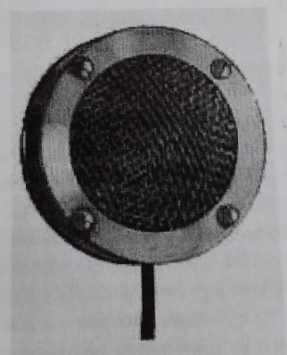
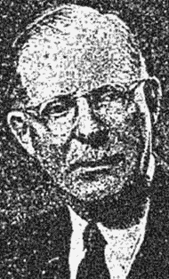
Ham radio sets were still fairly new inventions, appearing in the United States in the first decade of the Twentieth century. Tradition has it that in 1909, a gentleman named Robert A. Morton overheard an amateur radio transmission that would echo throughout the following decades. During a transmission the anonymous radio operator called a fellow operator putting up a new station a “ham.” It took until the 1920s for the term “ham” to be used to identify amateur radio operators. in the United States and other English speaking countries, but the term has endured into the Twenty-first Century.
F.H. Woodworth, President
In 1888, German physicist Heinrich Rudolf Hertz proved that radio waves existed and by the 1890s Italian inventor Guglielmo Marconi had adapted them into communications systems. These developments made it possible for amateur wired telegraphers to set up their own interconnected radio systems, or “ham” radio. Ham operators F.H. Woodworth and C.M. Chorpening solved their practical problem and pioneered a company that revolutionized the communications industry.
Up to this point in their ham operating careers, F.H. and C.M. had used a variety of carbon-based microphones, but as they gained more experience they were convinced that condenser type microphone would solve their static problem. They designed several condenser units and tried them on the air. Noticing the difference in transmission quality, several other ham operators visited their shacks, asking for their help in building or buying their innovative microphone. Motivated by their microphone success, the two innovators formed a partnership to build the new units for their friends, realizing that the condenser unit still had its imperfections and resolving to improve it.
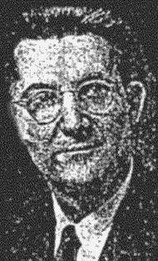
Other friends helped F.H. and C.M. develop their crystal microphone. A Cleveland friend, Charles E. Semple, had frequently visited their ham shacks, and he invited them to Cleveland for a return visit. Charles Semple had acquired a background in phonograph and loud speaker experience as well as working bench space in Brush Laboratories in Cleveland. His laboratory experiments involved testing the elements made from Rochelle Salts – sodium, potassium, and tartrate.
1C.M. Chorpening, Vice President
Charles Semple explained his laboratory work and introduced them to two of his colleagues, A.L. Williams, an electric and mechanical engineer, and Dr. C.B. Sawyer, a scientist. Charles and his colleagues demonstrated how the Rochelle Salts had the potential to transform mechanical energy into electrical energy and vice versa. This transformation process would radically improve microphones, quartz crystal-based phonograph pickups, speakers, recording heads, earphones, and other communications devices. Their collaboration produced Astatic’s first crystal microphone, Model D-104, manufactured in 1933. The amateurs and the scientists introduced a simple, low cost, dependable microphone for the ham operator rig.
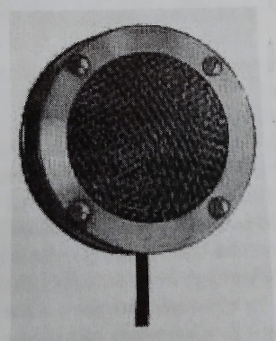
Model D-104
By 1933, F. H. Woodworth and C.M. Chorpening decided to incorporate a manufacturing and sales company to produce a line of crystal microphones, quartz crystal based phonograph pickups and recording heads for manufacturers and radio jobbers. F.H. Woodworth served as president of the new company and C.M. Chorpening, vice-president. They brought in their friend Charles Semple as designer and he later served as general manager until he died in 1939.
The crystal microphone manufacturers faced the task of naming their new company. It isn’t clear how or when the crystal microphone manufacturers decided on the name Astatic for their new company, but there are clues. Since F.H. and C.M. had engineering and science colleagues, it is possible that they collaborated and decided to name their new company after the scientific definition of astatic. The scientific definition of astatic is an instrument or system using a combination of magnets suspended in a uniform magnetic field on a single wire or thread to eliminate torque. Or, they may have chosen the simplistic definition of astatic, “no static”, one of the meanings of the a prefix in front of a word meaning no or not. Whatever the reasoning behind its name, the founders decided to call their new company, Astatic.
During its first year of operation in Youngstown, Ohio, Astatic had fewer than a dozen employees, but as usage and word of its excellent products spread, the company expanded both its employee base and its line of products.
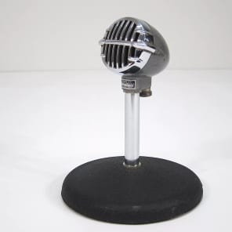
The Astatic Company introduced one of its most popular items, the JT-30 bullet-shaped microphone, in 1939. The JT-30 came in many different colors and later versions, and musicians of the time and of Twenty-First Century times welcomed it into their careers. Blues harp and harmonic players used it until the company finally stopped its production in 2013, after 74 years, Musicians including Junior Wells, Carey Bell, and George “Harmonica” Smith played Astatic enhanced songs throughout their careers.
Continuing to grow, even during the Great Depression, Astatic expanded to five locations in Youngstown and connections in Conneaut. The company built a solid reputation for dedicated employes and innovative and effective electronic products. When the United States entered World War II in 1941, Astatic changed its peacetime focus to aiding the war effort. In 1944, the company moved its major plant operations to Conneaut, Ohio, settling into a building dating to the early 1900s that had originally been the home of the Mazda Lamp Works of General Electric and later the Conneaut Woolen Mills on the corner of Jackson and Harbor Streets.
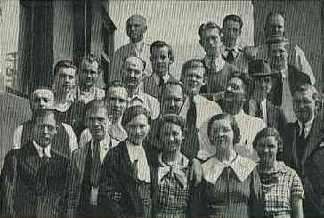
A group of early employees.
Helping to Win World War II
During the War, Astatic supplied microphones, pickups, and crystal cartridges to the American military, with some of its most important contributions being hydrophone and sonar devices. Astatic perfected and produced large amounts of Static Discharger for dispensing static electricity which accumulated on wing surfaces, fuselage, and tail assemblies due to friction in flight.
Astatic also designed and manufactured Co-axial Cable Connectors that the Army and Navy used exclusively for radio, radar, and sonar installations. During its peak production, Astatic shipped over 650,00 units in one month, becoming the world’s largest producer of these essential wartime items.
According to Carl Rowbotham, the Astatic founders petitioned the United States Government to allow them to raise the wages of their Astatic employees, although the government had frozen wages during wartime. The United States Navy recognized Astatic’s contributions to the war effort with many congratulatory letters for meritorious accomplishment and by awarding the company its prestigious United States Navy Certificate of Achievement.

After World War II, a Corporation
After World War II, Astatic Microphone Laboratory became the Astatic Corporation and continued to grow for the next several decades, expanding its work force to over 1,200 employees and creating worldwide markets for its large line of products. It established markets in 18 of the United States as well as internationally.

Astatic representatives could be found in:
Memphis, Tennessee Cleveland, Ohio New York, New York
Boston, Massachusetts Chicago, Illinois Dallas, Texas
Minneapolis, Minnesota Syracuse, New York Kansas City, Missouri
Atlanta, Georgia Indianapolis, Indiana Pittsburgh, Pennsylvania
Denver, Colorado San Francisco, California Detroit, Michigan
Los Angeles, California Philadelphia, Pennsylvania Portland, Oregon
Touring the Conneaut Headquarters
A quote from the Astatic advertisement in the Conneaut News Herald Sesqui-Centennial edition of July 2, 1946, illustrates the Astatic working experience.
“A trip through Astatic’s modern Conneaut plant and the amazing complexity of operations is a revelation in manufacturing achievement. Machines and equipment of the most modern design are utilized for the making of tools and dies, machining of parts, in assembly operations, finishing, and otherwise contributing to the manufacture of Astatic products.
Visitors to this Astatic Plant are deeply impressed with its modern equipment and facilities, with its fully equipped labor story and large engineering department, with its extensive tool and machine shops, its up-to-the-minute painting and drying department, its long busy lines of assembly workers, large office personnel, its clinic, its cafeteria, and other features.
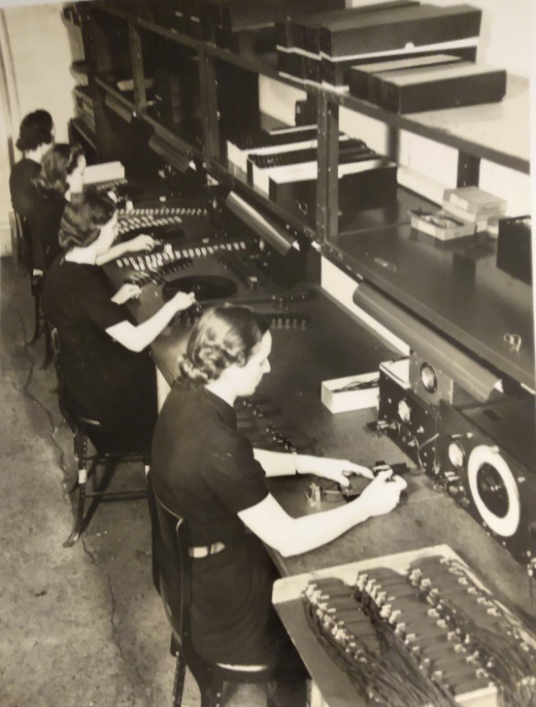
And one cannot fail to be impressed as well, with the constant supervision over these operations designed to insure through careful manufacture and constant testing, the ultimate performance of Astatic products in the field.”
Carl Rowbotham remembered that Astatic employees had to use a magnifying glass to properly set the precious stones like diamonds in the phonograph needless and the magnifying glasses were top of the line. Later in the program, a woman reminded Carl that F.H. Woodworth was a kind employer and even contributed to building houses for his workers on Broad and Sandusky Streets.
Carl and several other people in the audience agreed that Astatic was a wonderful place to work. The Astatic memories that Carl shared included the story that back in the 1950s, one of the Astatic recording tapes was used on the Perry Mason show. As time went on, cassettes began to replace reel to reel tapes and the market declined. Carl also displayed several Astatic artifacts and tape boxes that he distributed to the audience.
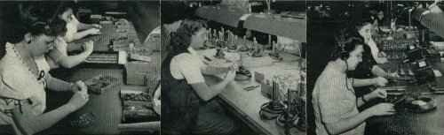

Left to right, (1) assembling needle chuck to crystal elements; (2) servicing microphone cables; (3) testing phonograph pickups.
Astatic After Hours
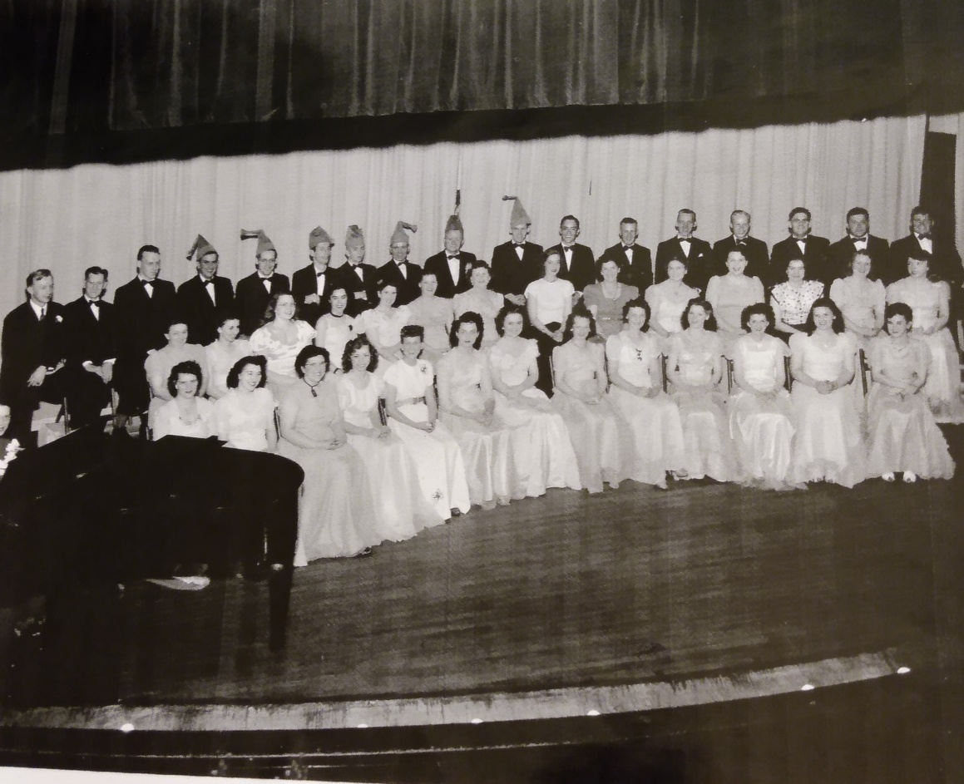
The
Astatic
Choir

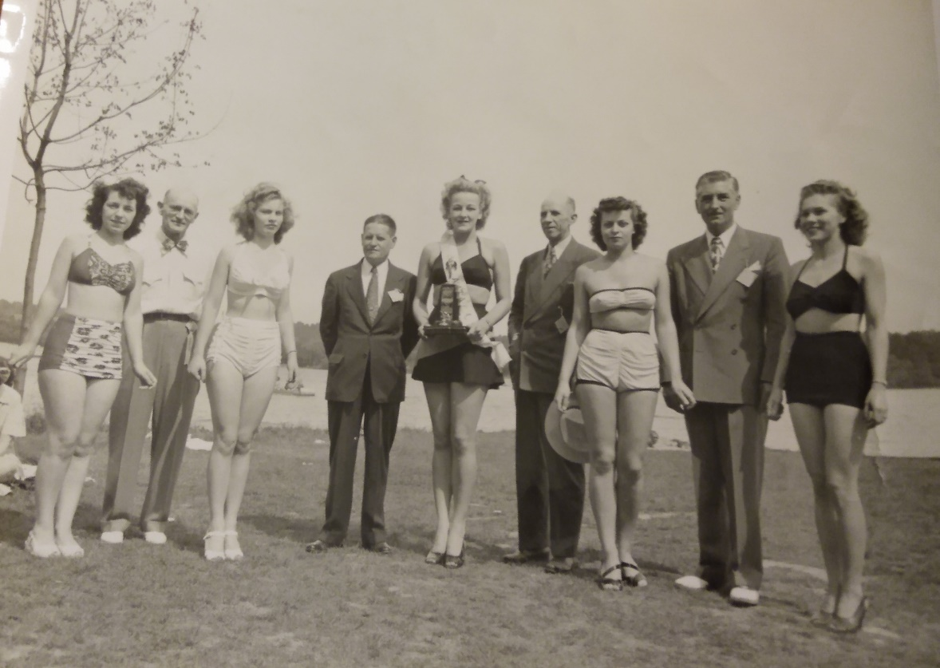
The Astatic Picnic
The Electronic Field Evolves
Ironically, the last decades of the Twentieth Century impacted Astatic as strongly as the first decade of the Twentieth Century, only in reverse. F.H. Woodworth and C. M. Chorpenning created Astatic in the first decades of the Twentieth Century and the company declined in the last decades of the Twentieth Century. New and faster technologies outpaced their original inventions and companies, and products were merged and reinvented. In 1988, Astatic formed CAD Professional Microphones as a division of the original Astatic Corporation and it reorganized again in 2000 as Omnitronics LLC. Later CAD, Astatic and Omnitronics combined under the CAD Audio brand, which features audio products and is located in Solon, Ohio.

The End of the Beginning
A Reverse Demolition: the End of the Beginning
For decades after the decline of business and the mergers, the Astatic building, once so bustling and busy, stood silent and deserted, shrouded in the mists of better times. In The Ashtabula Star Beacon of October 1, 2004, reporter Mark Todd continued the Astatic story.
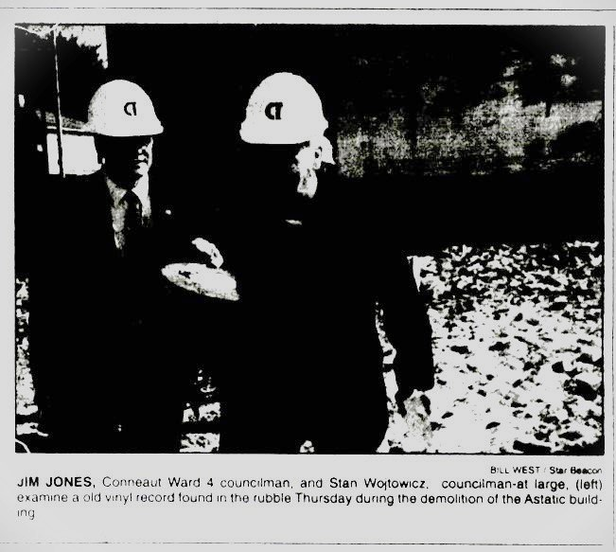
Hefting gold plated sledgehammers, local leaders including Jim Jones, (right) Conneaut Ward 4 councilman, and Stan Wojtowcz, councilman-at-large (left) took some token swings at the Astatic building on September 30th. After several councilmen managed to knock a few slivers of brick, they put down their shovels and conducted a brief ceremony to mark the start of the factory’s demolition. After the reverse ground breaking ceremony ended, the heavy equipment began to demolish the building.
“I’m ecstatic about the Astatic,” Conneaut Fire Chief Bim Orrenmaa said. The once proud factory had given the Chief and the Conneaut Fire Department years of frustration and worry over its unsafe and dilapidated condition. Councilman-at-large Jacob Chicatelli said, “This is a good day for the city.”
The seven councilmen posed for photographs with their hefty hammers that when properly lined up spelled “Astatic.”
A crowd of people had gathered to watch the demolition of the Astatic building. Nancy Griswold of Conneaut said her mother worked at the Astatic for many years. “As a child I used to sit across the street and wait for her to get off work.”
After the ceremony, people snatched keepsakes from the rubble ranging from Conneaut manufactured bricks to old records used to test the electronic equipment assembled there.
Crews had demolished the buildings adjoining the main Astatic building earlier, in the week clearing the way for a crane equipped with a heavy medal lance, The crane punched holes in the walls and roof lines, causing the walls to collapse. Spectators cheered when the factory’s large chimney fell to the ground.
According to Jim Matash, president of M&M Demolition of Vienna, the demolition of the Astatic would not be finished overnight. It would take a week to flatten the three-story building and another three or four weeks to haul away the rubble. “This is a big building, but we’ve been doing them this size for thirteen years,” he said.
The story summarized the history of the building and the final Astatic years. Constructed in the early 1900s, the building originally housed the Mazda Lamp Works of General Electric, later the Conneaut Woolen Mills, and in 1944, Astatic, its last tenant, moved into the building. Astatic thrived in that location with the electronic products it built enjoying an international reputation from the 1940s into the 1980s. In the 1980s, the company began to deteriorate and in 1987 it was dissolved, spinning off into Conneaut Technologies, Inc.
Empty and ignored, the Astatic building aged ungracefully. Neighbors complained about its appearance and condition, prompting city officials to campaign for its demolition. Inspectors feared sections of wall would collapse, so they barricaded sections of Jackson Street to keep pedestrians and vehicles a safe distance away. Legal issues and a parade of owners curtailed city efforts to demolish the building. Then in 2004, Conneaut City Council made the building’s demise its top priority and expedited the demolition by agreeing to pay the estimated $240,00 cost of the demolition and go to court to seek reimbursement from the owner Broad and Jackson Ltd.
The demise of the Astatic building is not the end of its story.
The Astatic Attitude

Conneaut. The name is still extensively known. Astatic. The name is still extensively known. Although Astatic is now a variation of the original inventions and accomplishments of F.H. Woodworth and C.M. Chorpening, they and the Conneaut community spread the name around the world through hard work, dedication, and belief in their product. Astatic kept reinventing itself and Conneaut can keep reinventing itself in spite of changing times and circumstances.
As Carl Rowbotham said in the closing remarks in his program about Astatic, “Astatic was a “hot place” to work. Conneaut, the home of Astatic, is also a hot place to live and work.

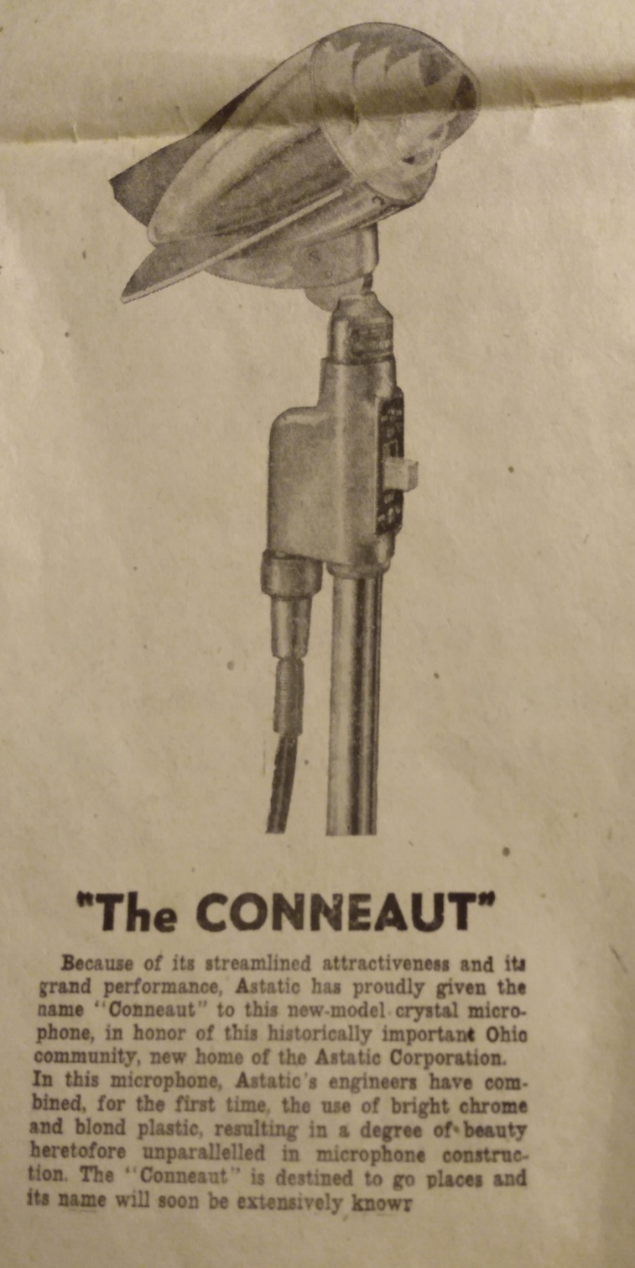

Conneaut Area Historical Society Museum
Membership Application
Single $10.00____ Couple $15.00_____
Family $20.00______ Patron $50.00______
Name________________ Address_________
City____________ State______Zip Code____
Phone Number___________
Would you be willing to volunteer at the Museum during the summer months? We are open Friday, Saturday, and Sunday from noon until 5 p.m., starting on Memorial Day and ending on Labor Day.
What day or time is best for you?

Thank you for your membership.
P.O. Box 563
Conneaut, Ohio 44030
Website: https://capturingconneauthistory.com/

Stamp

