The Ballad of H.O.M.E.S. : To Lakes Huron, Ontario, Michigan, Erie, and Superior
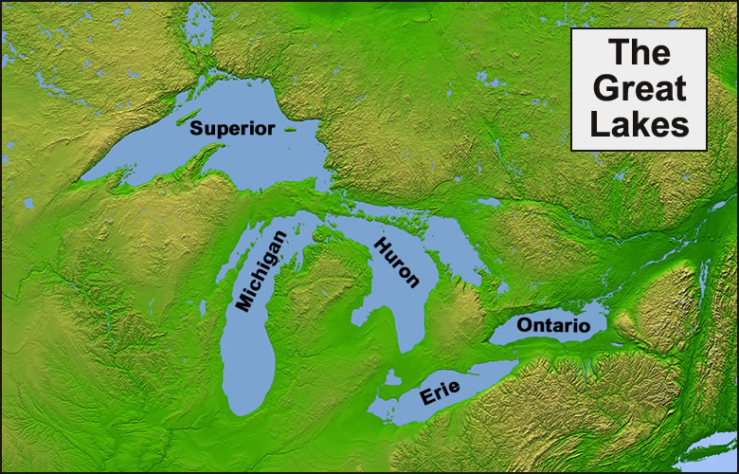
The glaciers they crept, and they carved lake faces,
The glaciers they melted and combined with the rain
Adding water links to all the new places,
Their melted down losses forever our gain.
Land people they paddled, voyaged lake trails,
Traveling with dugouts, skiffs and canoes,
Then ships poked the horizon with white sails,
Brought cargoes and people from wide world views.

The schooners and steamships and ore boats they came,
Digging trails of commerce deep in the land,
Forging light houses and keepers with landmark names,
Leaving steel rimmed boot trails in the sand.
Lake meadow waves race the sun and the thunder,
They’re old and they’re new and they roll right along,
They travel the lakes our waters of wonder,
They’re different but together they sing the same song!
Chorus
Shining waters so blue,
Islands and lighthouses,
The chain of the Great Lakes,
Wraps tight around me
Shining waters so blue
Islands and lighthouses,
The chain of the Great Lakes
Binds me and I’m free!

